|  |  |
| --- | --- |
| **Use Case** | Update existing customer information |
| **Actor:** | Sales assistant |
| **Pre condition:** | customer or someone in house notifies of changes or errors in stored data |
| **Goal:** | Actualization of data |
| 1 | Based on the customer ID or name the screen will show customer information. |
| 2 | The information like customer group, name, address, contact person information, discount rate or credit limit will be marked for change and waiting to be confirmed by Authorized sales assistant. |
| 3 | Confirmation/ Verification to the customer |
|  |  |
|  |  |
|  |  |

|  |  |
| --- | --- |
| **Use Case** | Registering new customer |
| **Actor:** | Sales assistant |
| **Pre condition:** | Potential customer contacts Lahjapaja or Lahjapaja contacts potential customer. |
| **Goal:** | Acquiring information about the customer and preparing it for the final acceptance of relationship with him. |
| 1 | Sales Assistant inserts company name, invoicing and delivery address, contact person information (name, tel. number, email, address), way of delivery, other possible info. |

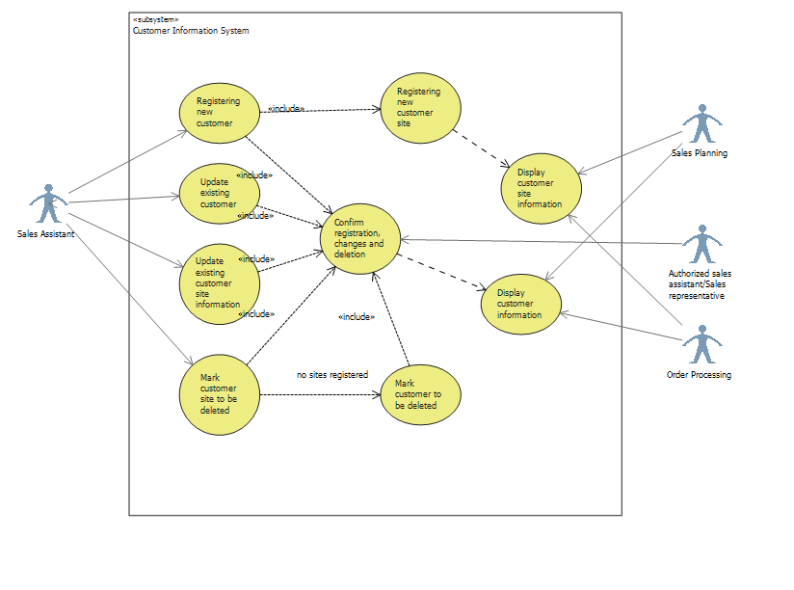

|  |  |
| --- | --- |
| **Use Case** | Registering new customer site |
| **Actor:** | Sales assistant |
| **Pre condition:** | Customer site will contact LahjaPaja or Lahjapaja will contact the customer |
| **Goal:** | Acquiring information about new customer site for the order processing purposes |
| 1 | Based on the customer ID or name the screen will show customer information/ The new customer information are being inserted into the system |
| 2 | The customer site information is added to other customer sites/ the customer site information is inserted as the consequent process of Registering new customer use case. The Site name, addresses, contact person information, way of delivery information will be inserted. |
| 3 | Verification of the customer site ID and stored site information |